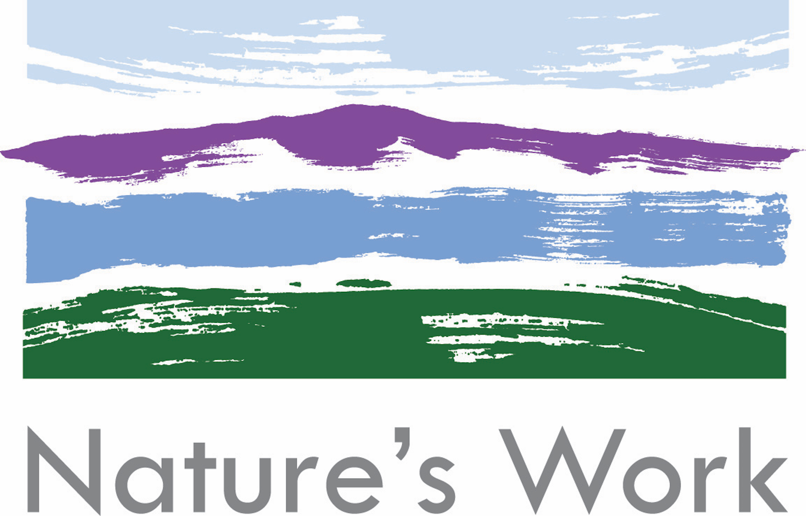

Privacy Policy

General policy
Here at Nature’s Work we respect your privacy. We will only use your personal information to administer your account and to provide the products and services you have requested from us.

GDPR statement
In May 2018, the EU General Data Protection Regulation (GDPR) replaces the existing 1995 EU Data Protection Directive (European Directive 95/46/EC). Nature’s Work currently complies with applicable data protection regulations and is committed to GDPR compliance across its relevant services when the GDPR takes effect May 25, 2018.

Third party sites
We do not share or pass on your personal data with any other websites or companies unless it is specifically about your course.

Affiliates
You'll find links on the Nature’s Work website to other websites operated by third parties. The content on these sites is not under our control. If you have any questions concerning these sites and the usage of them, we suggest that you contact the webmaster of the site directly.

Security
While we strive to keep the information that you supply secure, please be aware that the Internet is not a fully secure medium.

Usage of information
If required by law, we may submit your information to local or government authorities.
The information that we hold is the information that you complete on our booking form. This includes some personal information to allow us to look after you safely in a mountain or outdoor environment. We keep a paper copy of your booking form for 6 years after your course for our income records. By completing the form you consent to us keeping this record. At your request we can anonymise our records after your course.

We have a news mailing list that you may subscribe to from our home page. You will not receive marketing emails from us unless you are subscribed to our mailing list.

Policy changes
By using our site you agree to accept this privacy policy and are aware that our policy may change with time. Any changes to this policy will appear on this web page.

The information contained in the material in this website is only for information purposes. The material on this website does not constitute advice and you should not rely on any material in this website to make any decision or take any action.

In no event do we accept liability of any description, including liability for negligence (except for personal injury or death), for any damages or losses (including, without limitation, loss of business, revenue, profits, or consequential loss) whatsoever resulting from use of or inability to use this website. Where the content of this site describes a location the information is provided without any warranty as to whether there is access to that land, and it is the responsibility of the individual to ensure they have the right to access that land.

The pages contained in this website will almost certainly contain technical inaccuracies and typographical errors. The information in these pages may be updated from time to time and may be out of date. We can accept no responsibility for keeping the information in these pages up to date or liability for not doing so.

Nature’s Work makes no warranty that this website is free from computer viruses or any other malicious or impairing computer program. Nature’s Work excludes all liability for any illegality arising from error, omission or inaccuracy in material created and submitted by third parties. This website also contains links to other websites, which are not under the control of and are not maintained by Nature’s Work. Nature’s Work is not responsible for the content of websites that are referenced or linked on this website.

